1) If we want to valid any text field, we can directly give regular expression as shown below
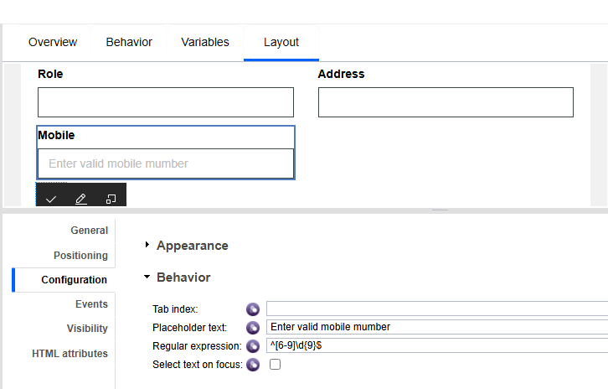

2) If we have two coach views in coach, in one coach view, we have drop down list and in other coach view, we have text boxes, if we select any one value from drop down list of first coach view, any text box in second coach view should become read-only or not visible
Coach view1:
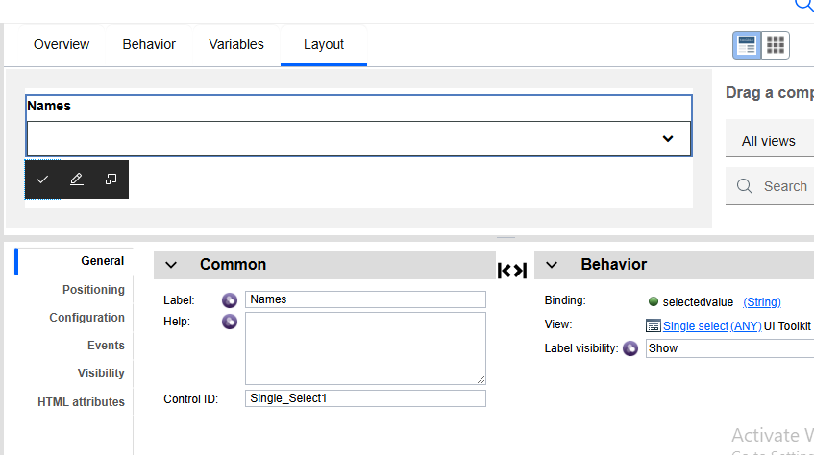

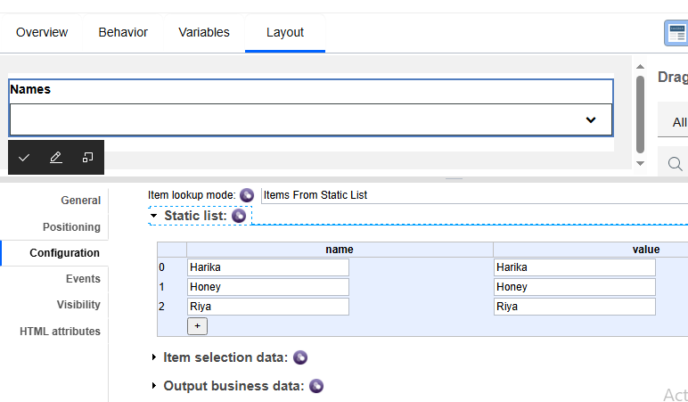

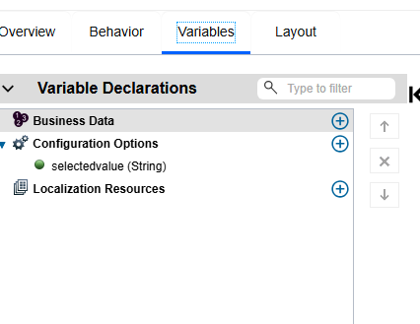

Coach view2:

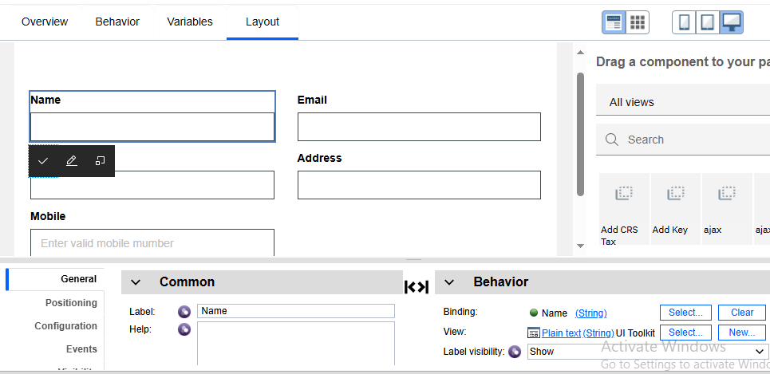

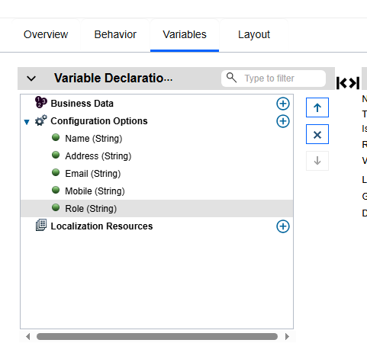

Coach:
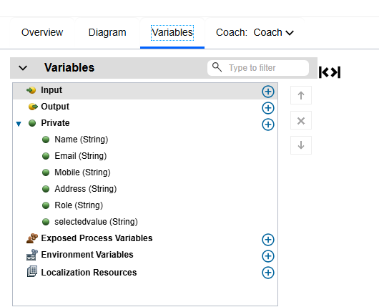

Here, we have take data and bind variable which we have bind to drop down list
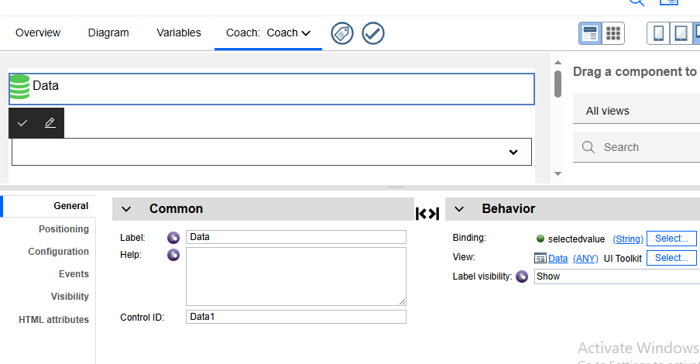
For dropdown we have bind value “selectedvalue”, same is bind to data, then values in drop down list will be stored in data, then we have to write script in on change event of data as below

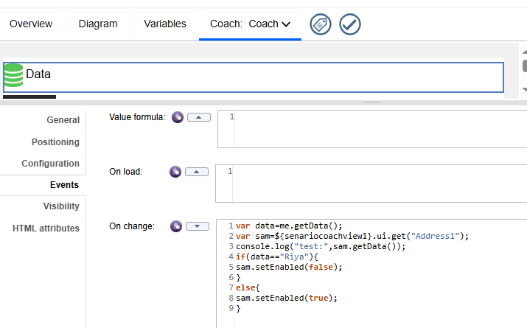

Here, senariocoachview1 is control id of second coach view and Address1 is control id of address text box in second coach view
So if we select value ‘Riya’ from drop down list, then address text box in second coach view will become read only.

var data=me.getData(); //getting drop down list values like harika,honey,riya
var sam=${senariocoachview1}.ui.get("Address1");
console.log("test:",sam.getData());
if(data=="Riya"){
sam.setEnabled(false);
}
else{
sam.setEnabled(true);
}

*visibility code
var data=me.getData();
var sam=${senariocoachview1}.ui.get("Text5");
console.log("test:",sam.getData());
if(data=="Honey"){
sam.setVisible(false,true);
}
else{
sam.setVisible(true,false);
}

*visibility code
var data=me.getData();
var sam=${senariocoachview1}.ui.get("Text5");
console.log("test:",sam.getData());
if(data=="Honey"){
sam.setVisible(false,true);
}
else{
sam.setVisible(true,false);
}

Result when we run coach:

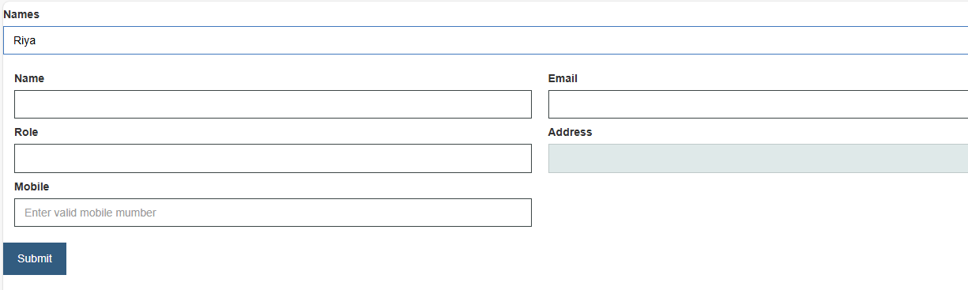
3) If we have drop down list with some values, before selecting values from list, one default value should appear there
Below, transaction purpose has drop down with values, so in service we have used ‘listAddSelected(0)’ then we are able to see ‘business payment’ which is 1st value in list, values started from 0 index. without selecting value from list.

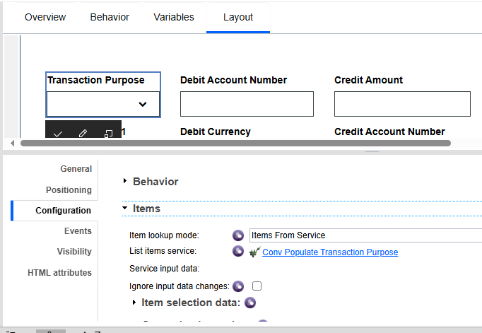

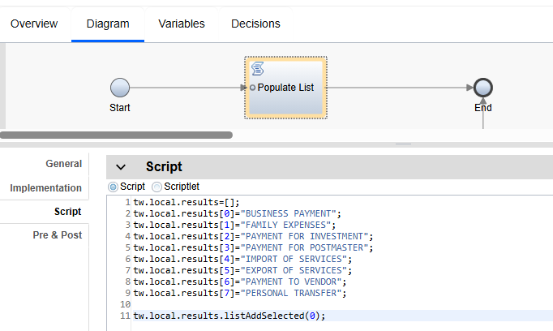

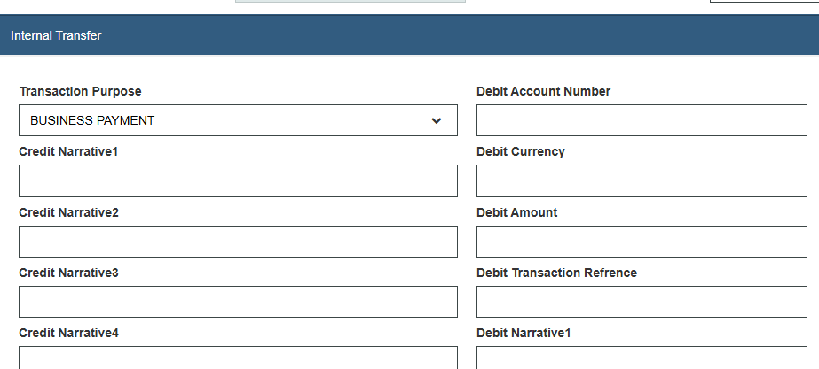

4) If we have one coach or coach view, if we select any one value from drop down list, any text box in that coach view should become read-only or not visible. Within same coach or coach view

var data=me.getData();
if(data=='Riya'){
${email}.setVisible(false);
}
else{
${email}.setVisible(true);
}
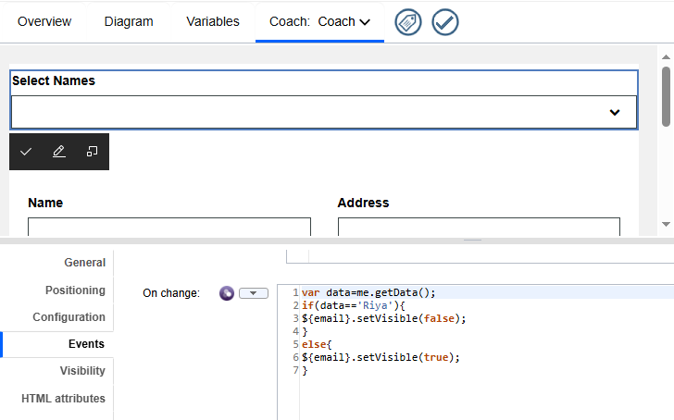

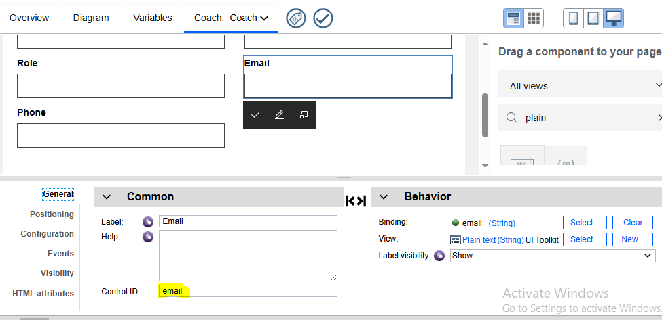
5) Another way for visibility
Here, we bind variable name to textbox and we have another text box with name ‘another way for visibility’, for that we have written condition
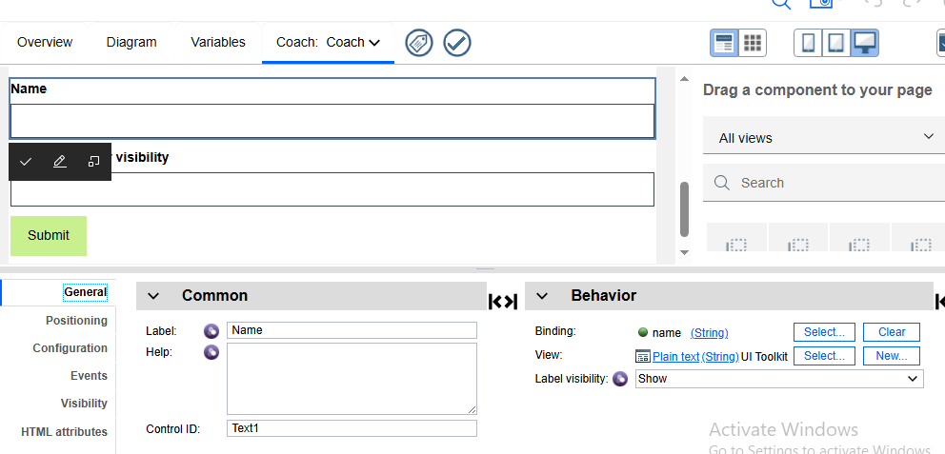

Here, we written condition like if above text box ‘name’ is empty, then the textbox ‘ another way for visibility’ should be hidden. Otherwise it should be visible, we have to use rule in visibility property.
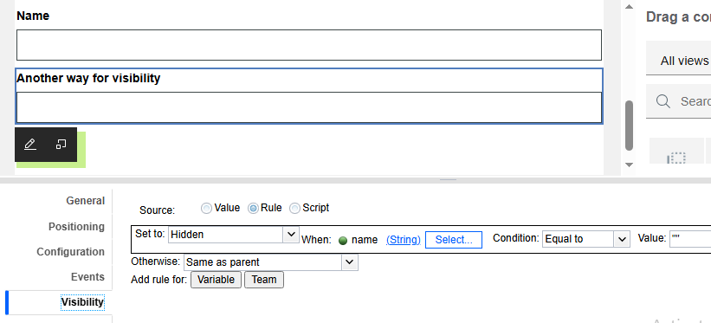
Another visibility:
If we have one text field, if that text field has entered any data and click on the button, then only other text field should be visible, otherwise, it should be hidden
Here, Type_Ahead_Text1 is field to which we enter the data and Text1 is field which is visible based on condition
First, we should hide the Text1 field by writing code on onload “${Text1}.setVisible(false,true);”
“${Text1}.setVisible(!!${Type_Ahead_Text1}.getData(), true);// Text1 field will be visible, if we enter any value in Type_Ahead_Text1 field
We will write these conditions in button events.

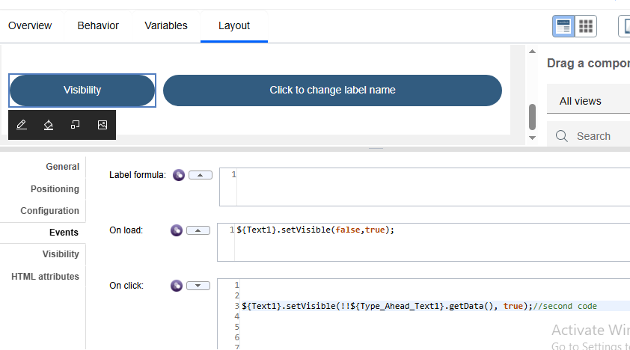

6) Change label name
Here, we have label name plain text, we will change that by clicking button
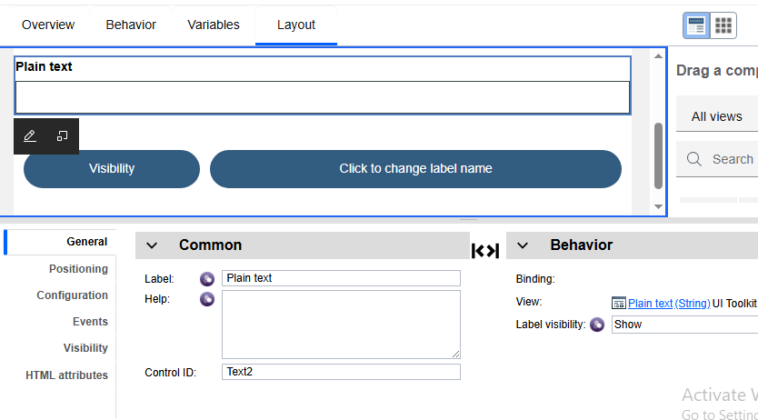
Button on click : ${Text2}.setLabel('change label name by clicking button');
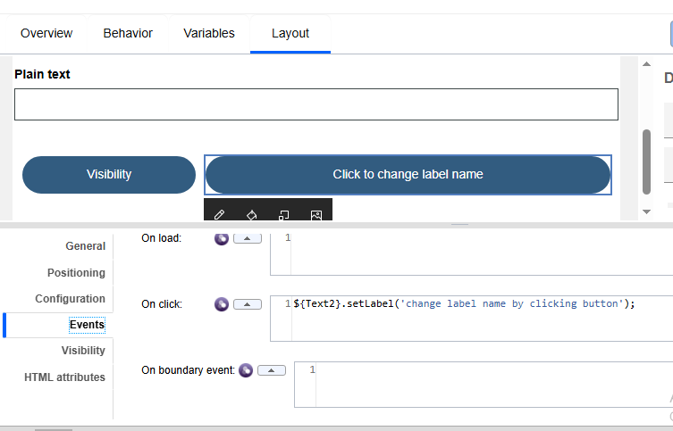
7) HTML to PDF
Here, we will convert html data to pdf and we will print the pdf, we will do this in coach
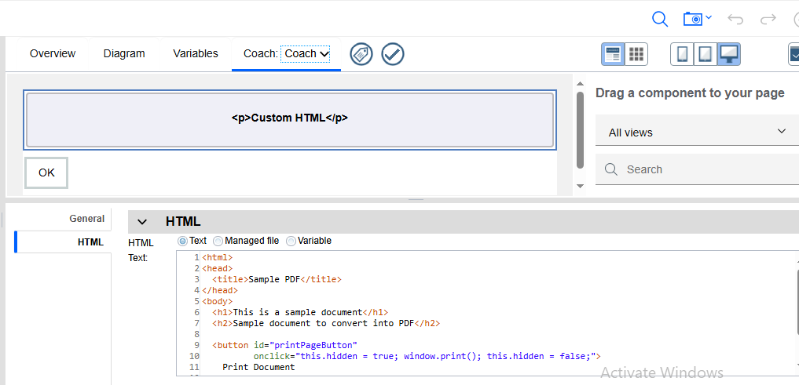

<html>
<head>
<title>Sample PDF</title>
</head>
<body>
<h1>This is a sample document</h1>
<h2>Sample document to convert into PDF</h2>

<button id="printPageButton"
onclick="this.hidden = true; window.print(); this.hidden = false;">
Print Document
</button>
</body>
</html>

Result:

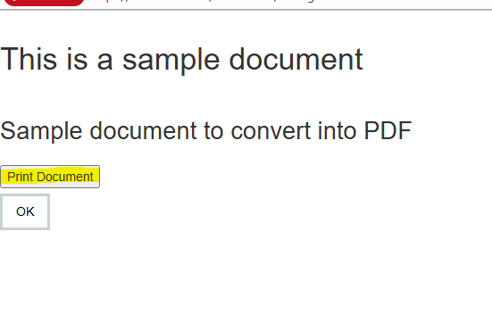
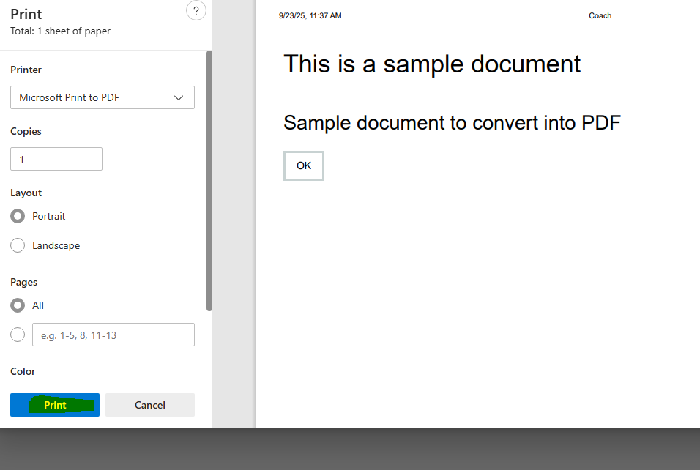

8) Fetching States and Districts by selecting country (drop down scenario)

Coach:
Bind the variables country, state and district to three drop downs in coach view.
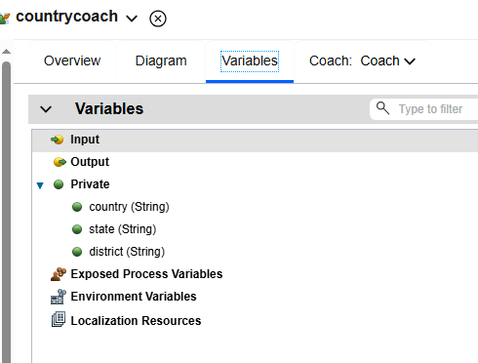

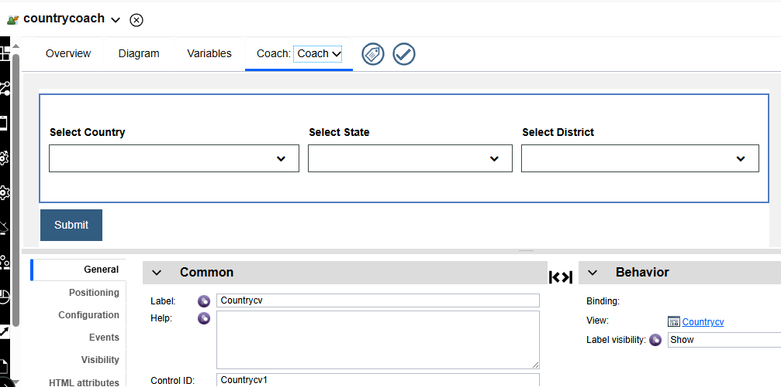

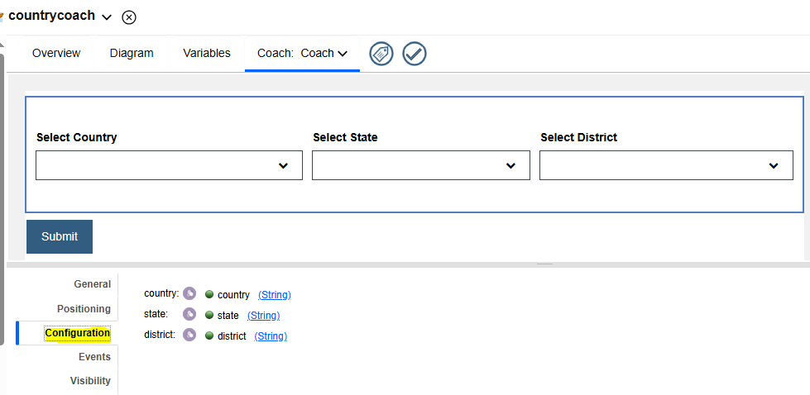

Coach view:

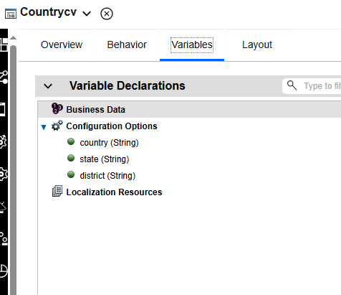
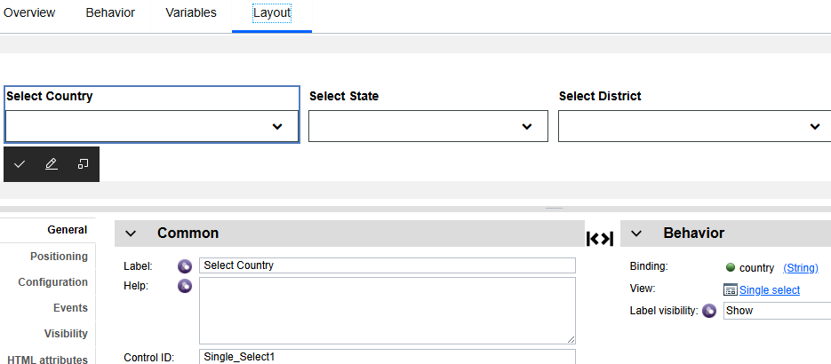

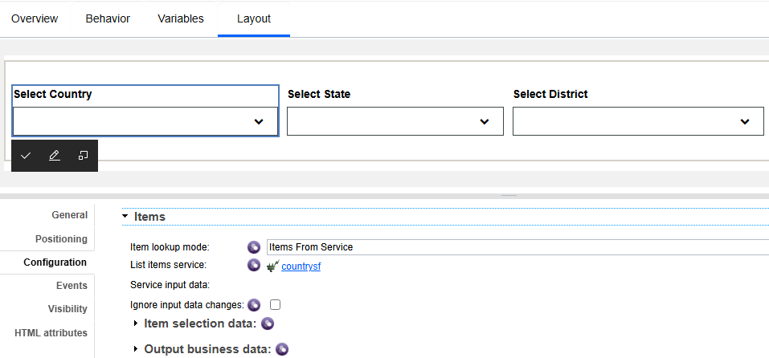

Countrysf: create country, state and district service flows

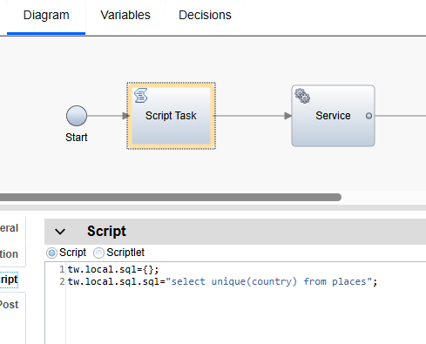

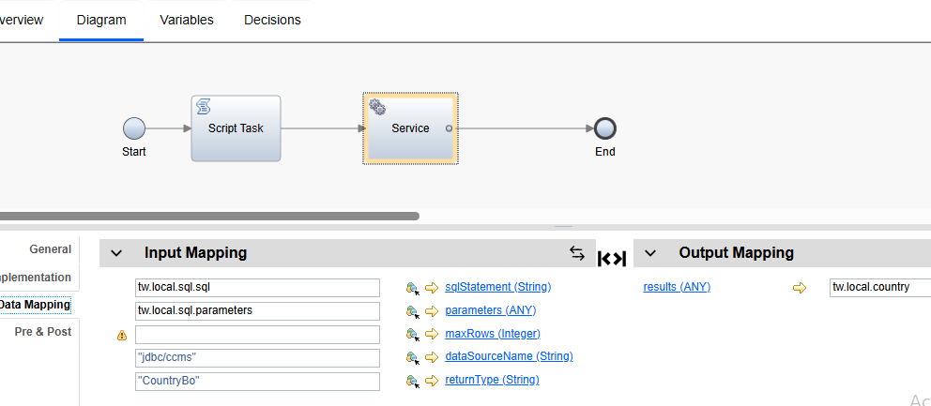
Here, in post execution script, we are parsing country output to results.
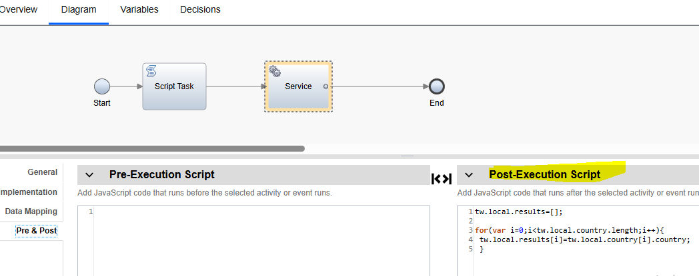

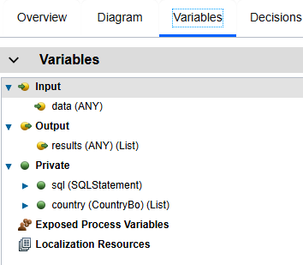

For state service flow, in configuration, we have to give country as input and for district service flow, in configuration; we have to give state as input
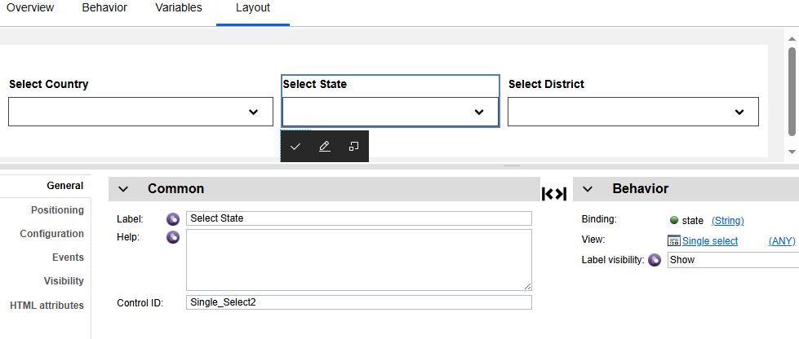

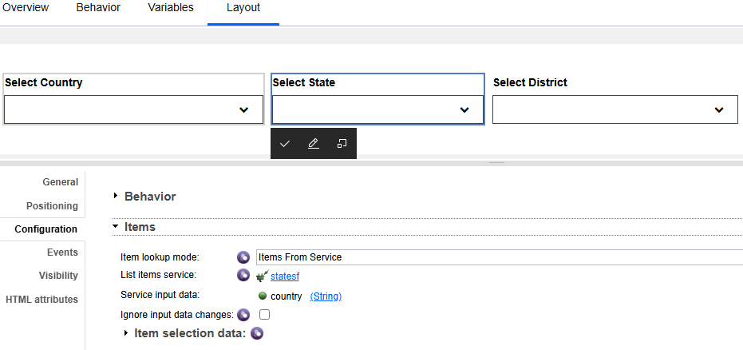

Statesf:
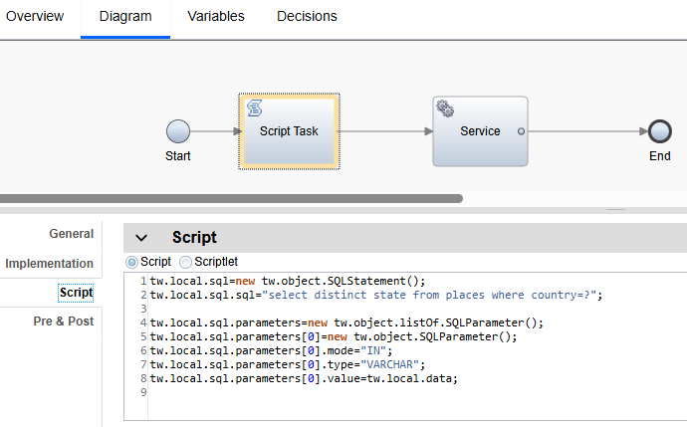

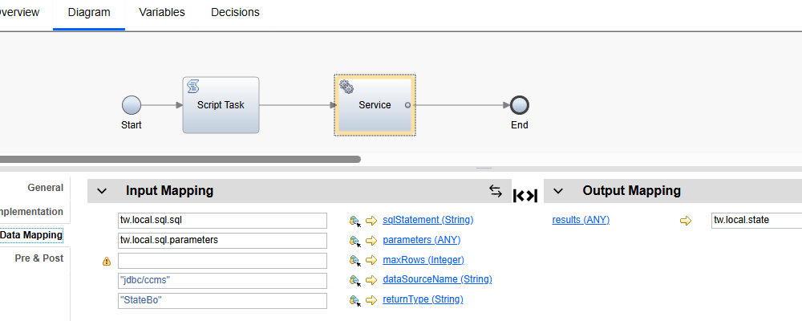

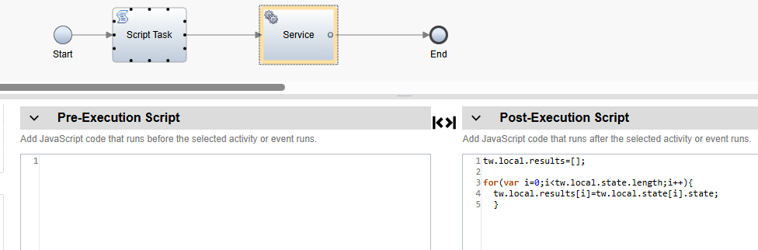

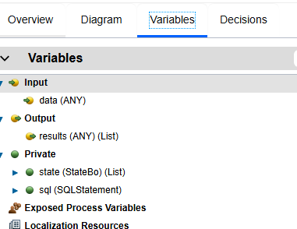

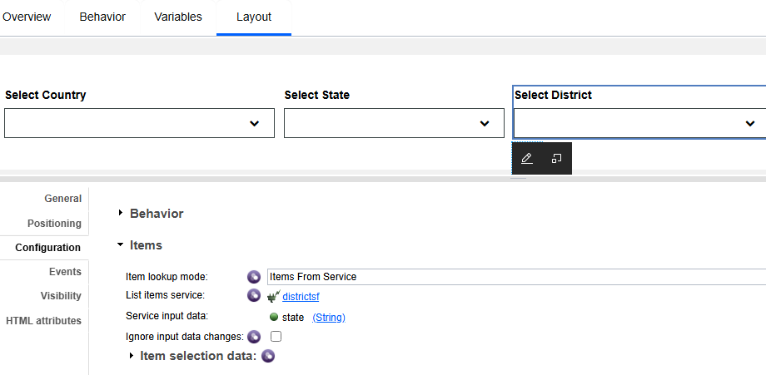

District service flow is also same as state service flow

Result:

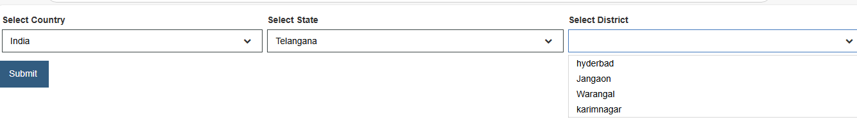

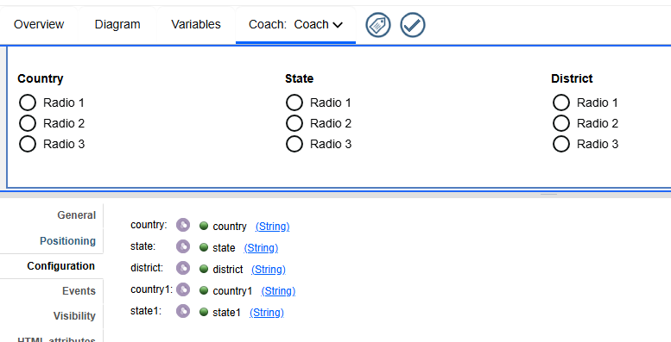

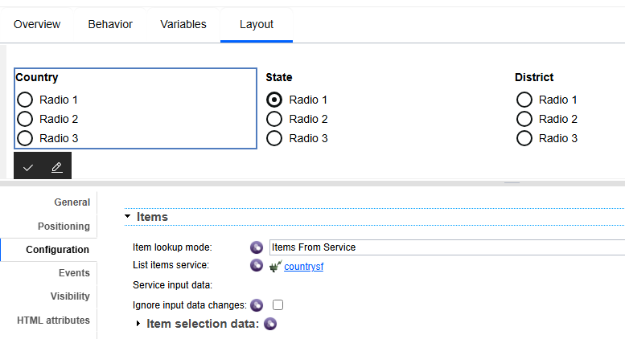

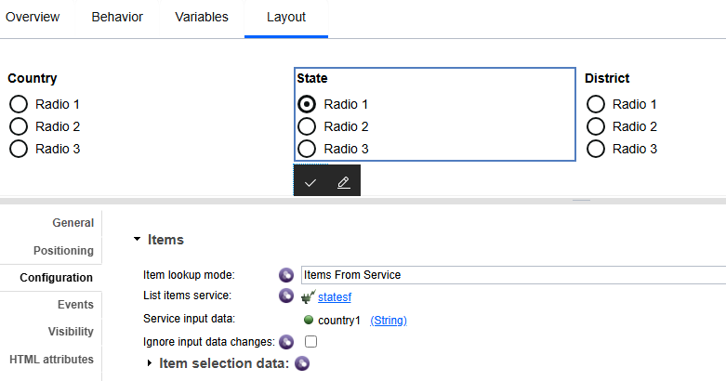

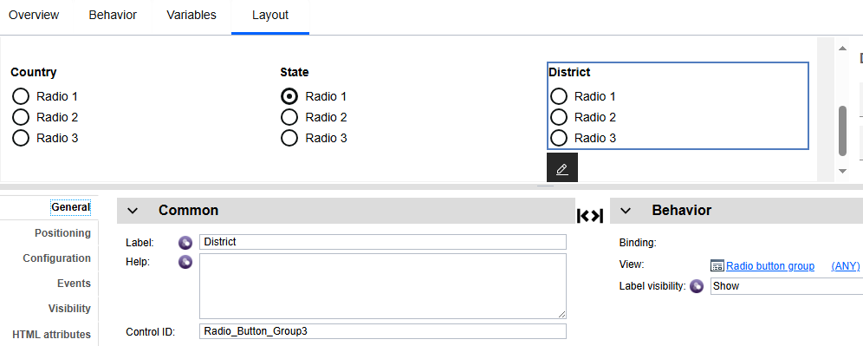

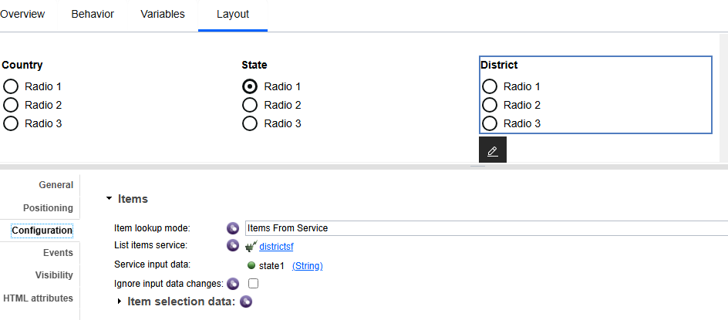

Result:

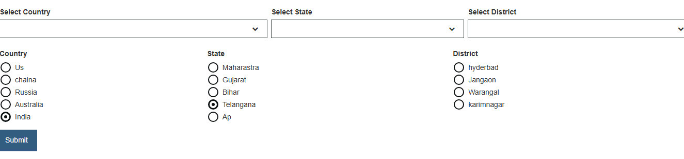

9) File net Integration:
File net is mainly used for document management, when we upload the documents, it will be uploaded to the file net
Firstly, we have to integrate file net to bpm in servers, in servers, we have to give the name as filnet and select type as enterprise content management server.
They will provide details like, hostname, port, context path, repository, userid and password, fill that all details
Click on secure service checkbox and always use this connection information and test the connection.
Ecm document authorization service: this service is used for exception handling, it used to send the mail when we get any error on any activity. It will be used throughout the process
After integrating file net to bpm, we have to add content management toolkit to our process, it contains ECM document list, ECM document upload so on… , these all components will be used to upload the documents, fetch the documents and view the documents
After that we have to implement this documents in our process, we have added create one coach and in that coach, we have to drag ECM document list (enterprise content management) and for this ECM document list, we have to bind ECM Document info (BO), it is readonly (default bo), it has properties like content url, object id and service name
For ECM document list, in configurations, we have to give details like where we are uploading documents.
ECM document list configurations:
Content Management:
Allow create, click checkbox
Allow document deletions, click checkbox
Confirm on deletion, click checkbox
Filter:
CMIS query filter: bind service : documentECMOptions.cmisQuery (string)
We have to build the cmis query, it is mainly used for, when we are uploading the files in file net, we have to declare the file properties and insert those properties to file net by using cmis query
Search service : bind service, it is default ECM service (it is used for fetch documents)
Content management advanced:
ECM server configuration name: file net (server name, when we integrated the filenet , we gave server name as filenet)
Document object type id: processid (cmis service property, which process we are using, we have to give that process processid)
Folder path : filenet user will provide the folder path for uploading document, files will be stored in that particular path
Cmis service:
Cmisquery:”select cmisname(document name),creation date, created by , lastmodified date from accountservice”; when we fetch document above document, we can see document name, creation date….
Parentfolder path: String(tw.env.documentuploadfolderpath), filnet user provided this path
Default properties: when we click plus symbol for uploading documents, we will select document and below the document, we can have some default properties like document type, document title, customer name so on.., we will select that document and enter the default values like type, name… and the upload the document.

Folder creation for uploading documents, we have to create one service
We will pass variable like unique reference number and application id
In service, we will use “content integration task “component and in implementation, we will use server: filnet and operation: ‘get folder by path’, we will give path and check whether that path is available , if it is available fetch target path otherwise, we have to create folder by giving server: filenet and operation: ‘create folder’ in implementation.

10) Sending mail via service

We have to create service and in script- let we have to write sample mail body and bind the variable
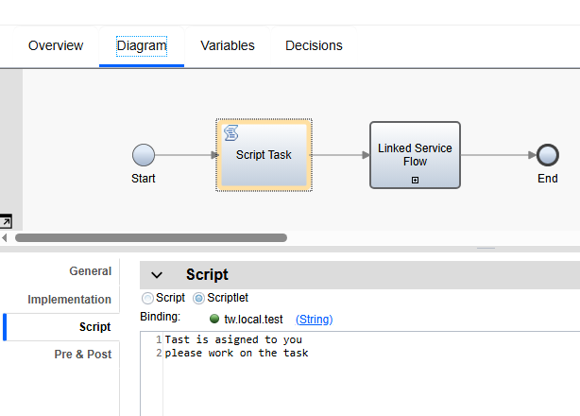

We have to use linked service flow and in implementation, we have to select ‘send email via smtp’ service
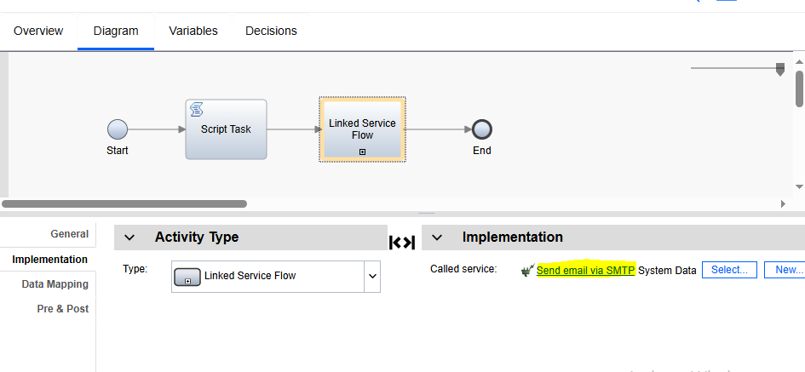
In data mapping, we have to give smtp host, to and from mail id’s, subject, and bind variable in message text which we have bind in scriptlet & context type “text/html” and we can add cc, bcc mail id’s if required
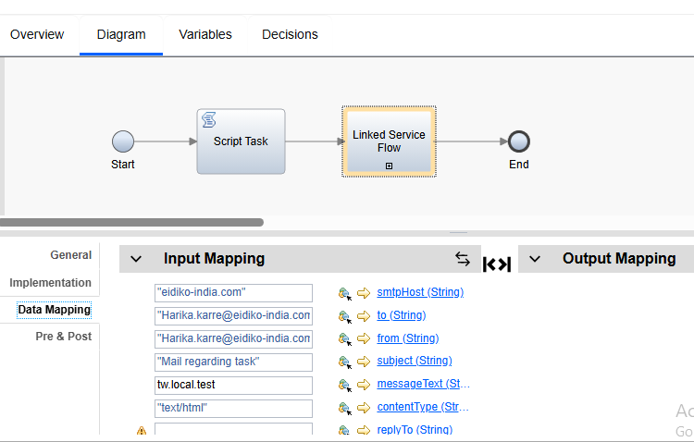

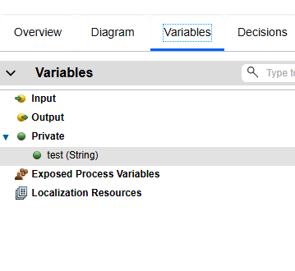
Run the service, then mail will be send from bpm service to mail id which we have provided
Result: Here we receive the mail from bpm
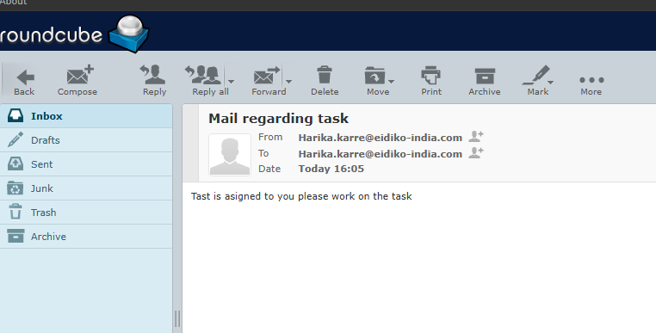

Another mail service
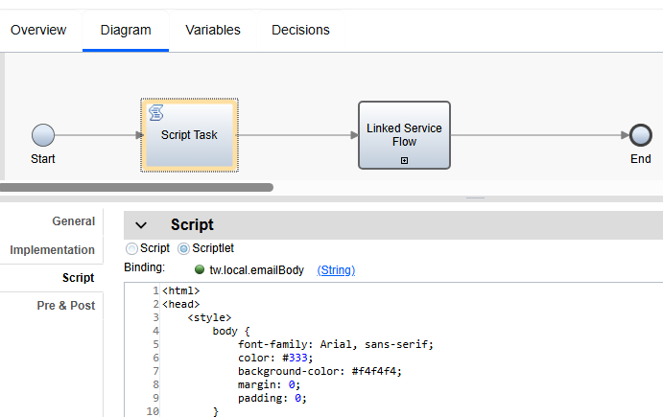

Sample mail format script:
<html>
<head>
<style>
body {
font-family: Arial, sans-serif;
color: #333;
background-color: #f4f4f4;
margin: 0;
padding: 0;
}
.email-container {
width: 100%;
max-width: 600px;
margin: 0 auto;
background-color: #ffffff;
padding: 20px;
border: 1px solid #dddddd;
box-shadow: 0 0 10px rgba(0, 0, 0, 0.1);
}
.email-header, .email-footer {
background-color: #4CAF50;
color: white;
text-align: center;
padding: 10px 0;
}
.email-content {
padding: 20px;
font-size: 16px;
line-height: 1.6;
}
h2 {
color: #4CAF50;
font-size: 20px;
margin-bottom: 10px;
}
.content-table {
width: 100%;
border-collapse: collapse;
margin: 15px 0;
}
.content-table th, .content-table td {
padding: 12px;
border: 1px solid #dddddd;
text-align: left;
}
.content-table th {
background-color: #4CAF50;
color: #ffffff;
font-weight: bold;
}
.content-table td {
background-color: #f9f9f9;
}
.highlight {
color: #4CAF50;
}
</style>
</head>
<body>
<div class="email-container">
<!-- Email Header -->
<div class="email-header">
<h1>Customer Details</h1>
</div>

<!-- Email Content -->
<div class="email-content">
<p>Dear <span class="highlight">Honey</span>,</p>
<p>Thank you for providing your details. Below are the details we have on file for you:</p>

<h2>Eidiko Customer Details</h2>
<table class="content-table">
<tr>
<th>First Name</th>
<td>Harika</td>
</tr>
<tr>
<th>Last Name</th>
<td>Honey</td>
</tr>
<tr>
<th>Contact</th>
<td>876756</td>
</tr>
<tr>
<th>Email ID</th>
<td>h@gmail.com</td>
</tr>
<tr>
<th>City</th>
<td>Hyd</td>
</tr>
<tr>
<th>PIN</th>
<td>7565657</td>
</tr>
</table>

<p>If there are any changes to be made, please contact our support team.</p>
<p>Best regards,<br>
The EIDIKO Team</p>
</div>

<!-- Email Footer -->
<div class="email-footer">
<p>&copy; 2024 Eidiko System Integrators. All rights reserved.</p>
</div>
</div>
</body>
</html>
;

Here, we can see how we can use mail service in process, here we used two user tasks and added team filter and team retrieval coaches and added boundary event and type is timer to one user task and that boundary event is connect to email service and service is connected to end .

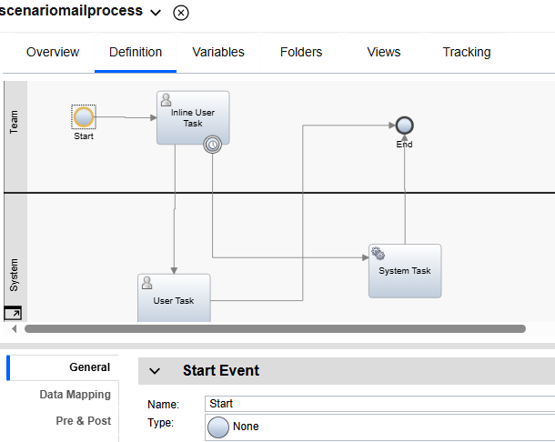

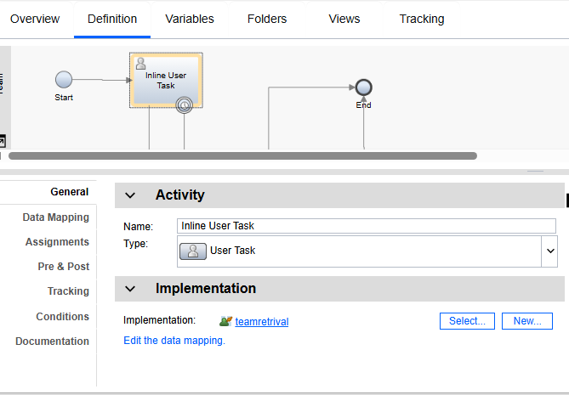

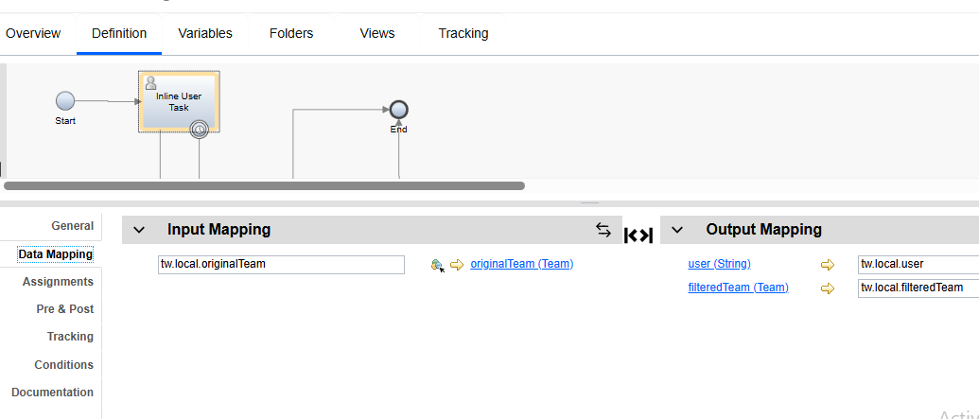

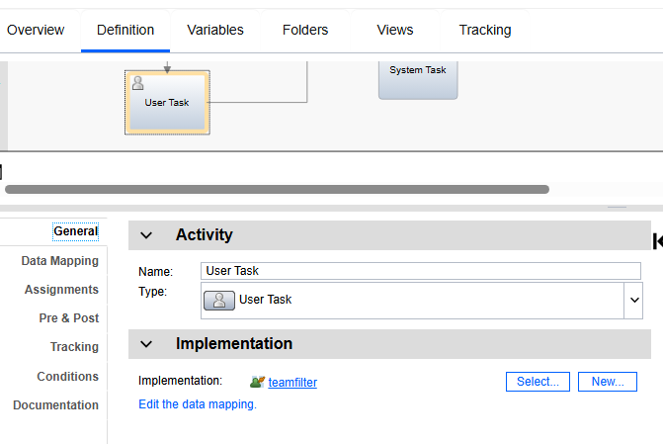

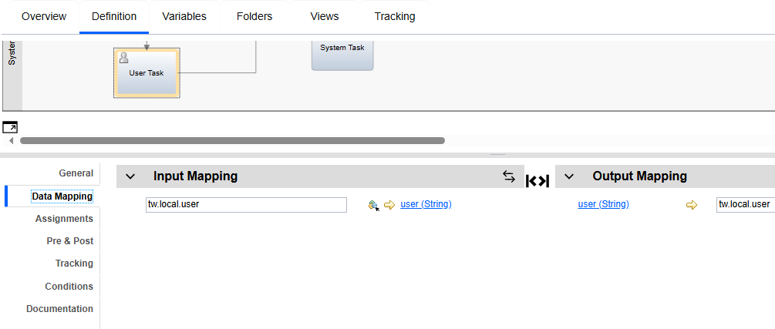

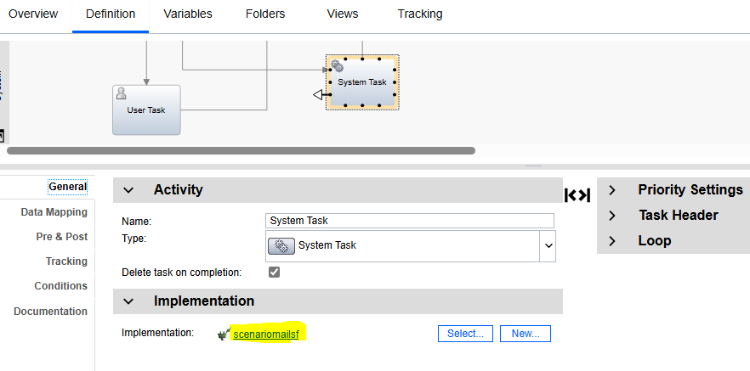
In boundary event we written condition like
“Triggered on: after start of step”
Interrupt activity: check the check box
Before or after difference: 1 minute
Tolerance interval: 0 minute
So, here, when we run the process, first user task has team, that activity is assigned to team, If user not claim that activity and work on that activity within one minute, after one minute the service will be triggered and mail will send to that user saying the task is assigned to you and that process will interrupt and stop
In general, we can give one hour or more time to claim the task for user and if he doesn’t claim that task, the mail will be send. In this way, we use mail service in process.

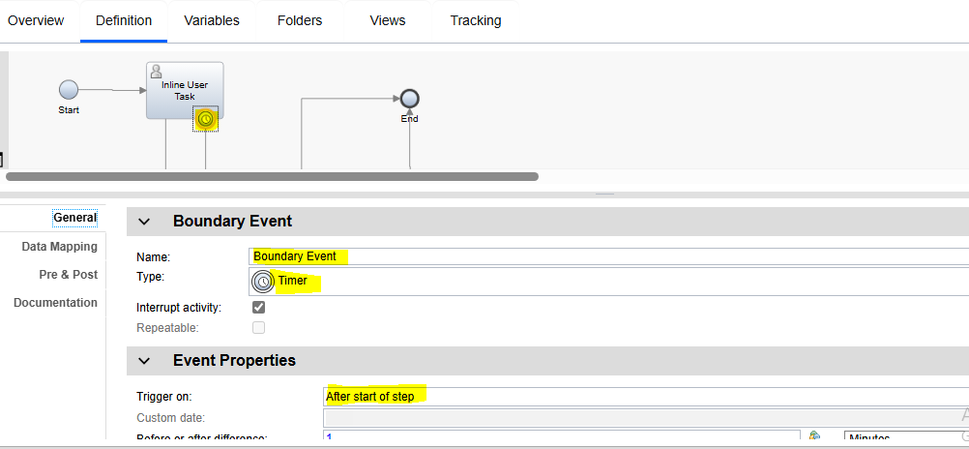

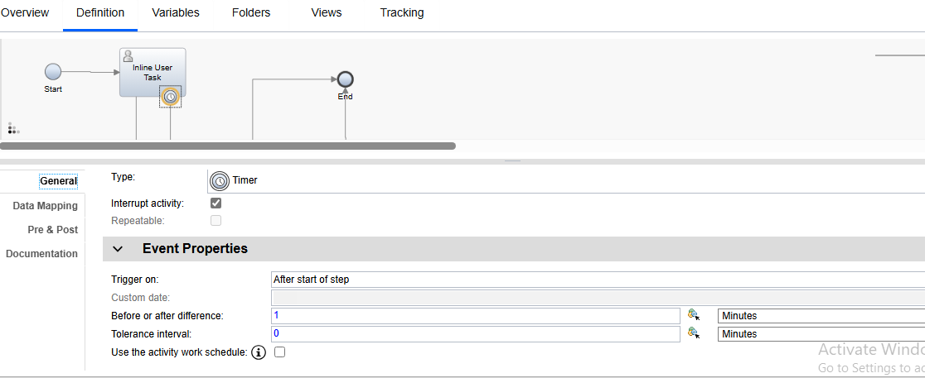

Here, we have attached boundary event to mail service and mail service to user task and remaining all details are same as above, so until user claim that task mail will be repeatedly send to that user for every hour or every 40mins according to the time we declared. when user claim that task and complete that task, then only it will stop sending the mails.
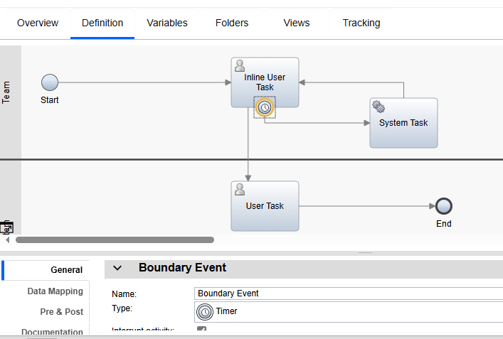

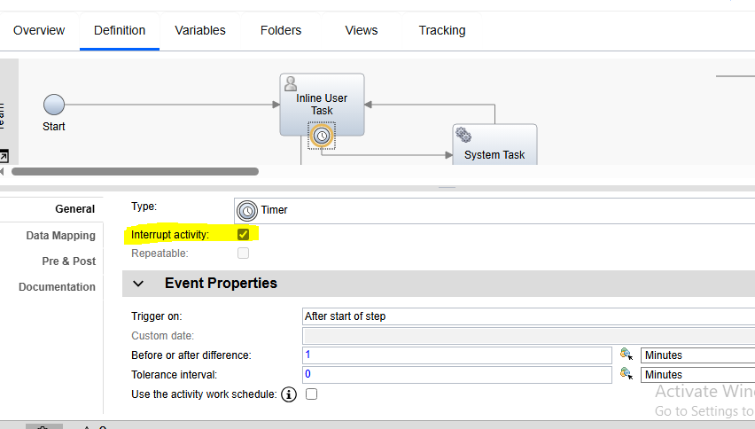

11) In the workflow process, both the Maker and Checker activities are assigned to the same team.
The Maker activity must be assigned to all members of the team.
However, for the Checker activity, one specific member of the team must be excluded from the task assignment.
The excluded member should not receive or be eligible to claim any Checker tasks.

Technical Requirement Statement
Configure task assignment logic such that:
- The Maker task is routed to all users belonging to the specified team (Team Name: <TeamName>).
- The Checker task assignment logic must filter out one specific user (User ID: <UserName> or <UserID>) from the same team before creating the task assignment list.
- The exclusion should be handled dynamically through a custom script or service that removes the specified user from the team user list during Checker task assignment.
scenarioteamfiltersf: service flow to eliminate specific user from the team

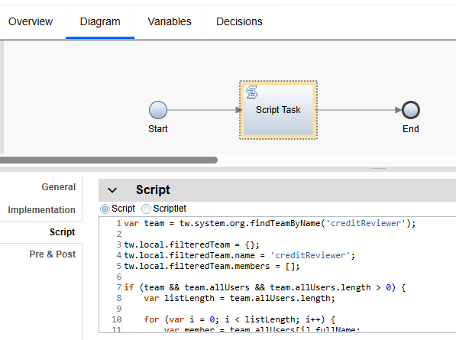

var team = tw.system.org.findTeamByName('creditReviewer');

tw.local.filteredTeam = {};
tw.local.filteredTeam.name = 'creditReviewer';
tw.local.filteredTeam.members = [];

if (team && team.allUsers && team.allUsers.length > 0) {
var listLength = team.allUsers.length;

for (var i = 0; i < listLength; i++) {
var member = team.allUsers[i].fullName;

// Skip the current user
if (tw.local.user && member == tw.local.user) {
continue;
}

tw.local.filteredTeam.members[i] = member;
}
}

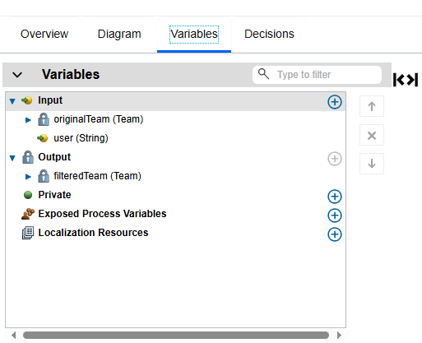

Here, we gave default value; we gave default user as rahul to eliminate from the team
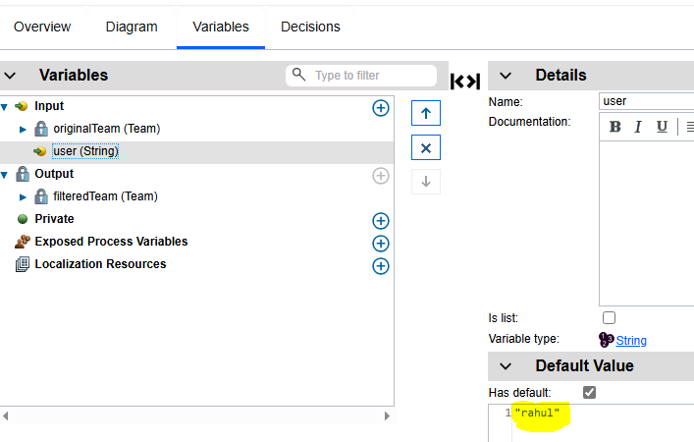

After debugging service flow, below in filtered team, item1 is empty; rahul is eliminated from the team
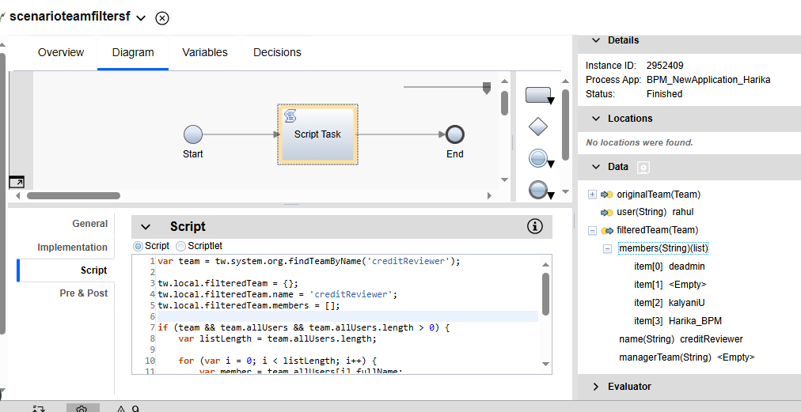
In process, we assigned “creditreviewer” team to maker
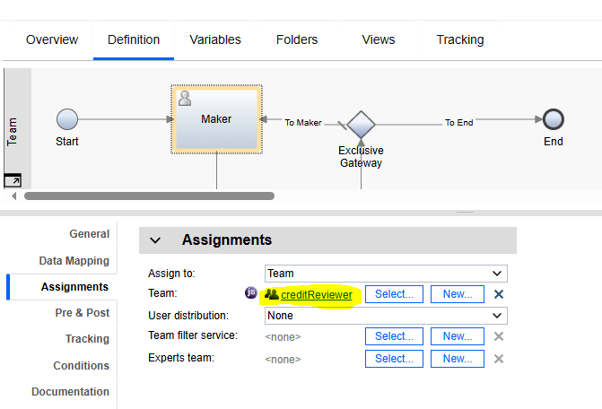

Team:
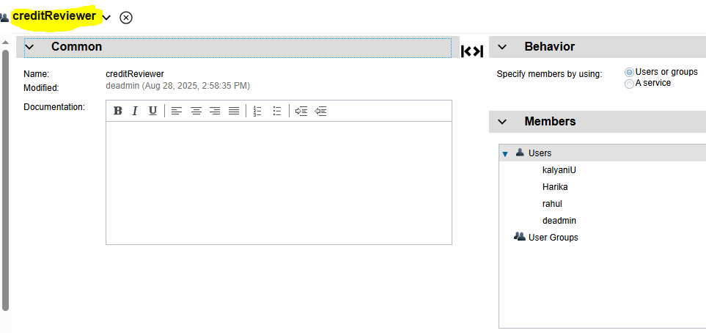
For checker, we have assigned same team and also added team filter service that is scenarioteamfiltersf, this service is used to eliminate required person from the team

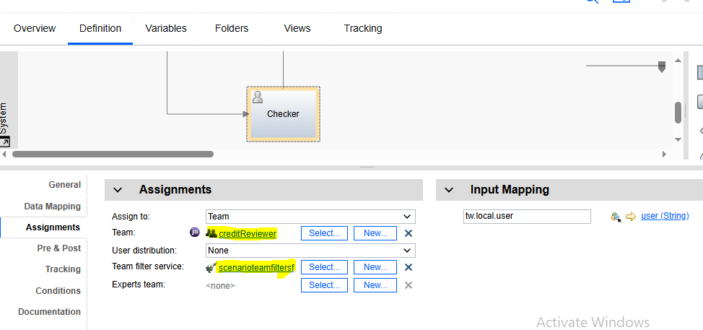

To check whether it is working fine or not, we have started the process and went to process portal, in that we can see this process, we can claim that process and assign to members of team used in the process, for maker everyone can claim and complete the process because we did not used any filter service
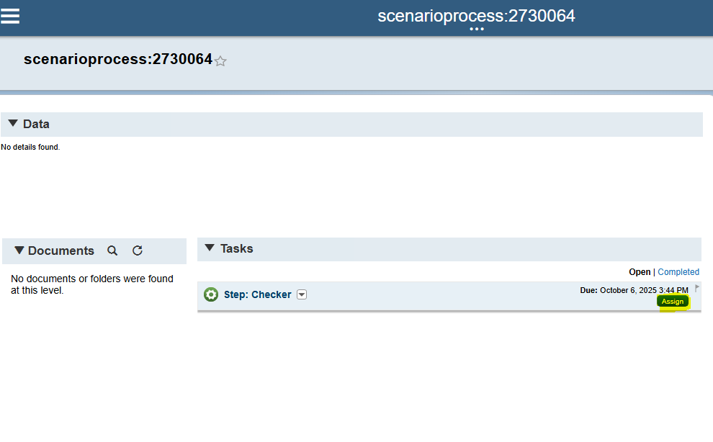

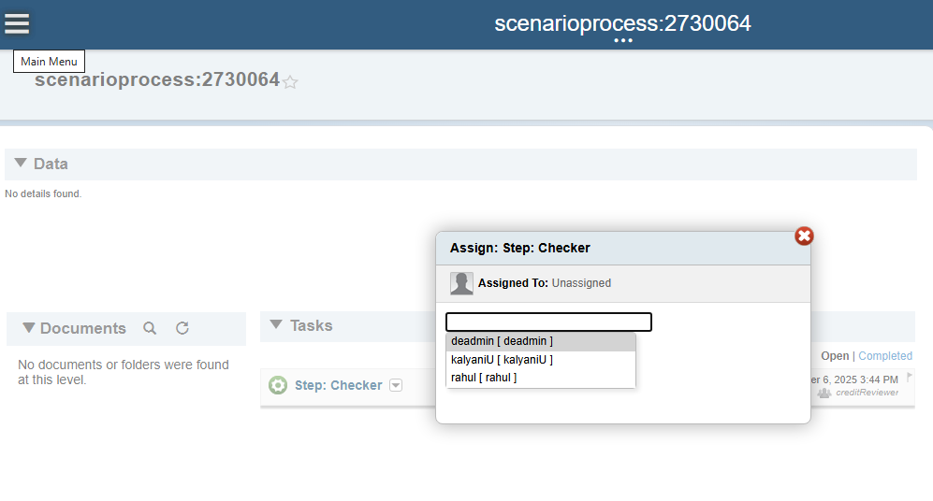

Here, we have assigned checker to rahul, but rahul is eliminated from the team, when rahul is try to claim the task, it will show the error as “you are not authorized to work with this task”

